Model Reduction for Aerodynamically Driven Limit Cycle Oscillations
K.J.Badcock and M.A.Woodgate
Computational Fluid Dynamics Laboratory
Department of Engineering
University of Liverpool
Liverpool, UK
K.J.Badcock@liverpool.ac.uk
Abstract
This paper describes several methods that have been developed to allow a systematic approach to exploiting a coupled CFD-FEM code for predicting aerodynamically driven limit cycles. The formulation of the coupled code is summarised, with emphasis on the approach for passing information between the CFD and FEM grids. Then eigenvalue stability methods are described. Finally a projection of the coupled system onto the critical mode to obtain a two degree-of-freedom model which can predict the limit cycle amplitude is given. Results are presented for model wings and a generic fighter.
1 Introduction
Nonlinear aerodynamics can contribute to limit cycles on aircraft. Examples include bounded aeroelastic responses where shock waves limit the amplitude, and wing rock where leading edge vortices interact to cause a finite amplitude rolling motion. Military aircraft have been found to exhibit limit cycle responses such as these in flight (e.g. F-16 store induced aeroelastic LCO).

Computational fluid dynamics has the capability to predict many of the nonlinear aerodynamic phenomena relevant to the development of LCO’s. One problem with using CFD for prediction of LCO’s comes from the inherent computational cost of time domain calculations. In particular, LCO’s can take many cycles to settle to the periodic state, meaning that the calculation becomes very expensive due to the large number of time steps required. This paper describes work towards allowing a systematic model reduction from a large dimension coupled CFD-FEM model to a small order nonlinear model that has the ability to predict limit cycle amplitudes.

The paper continues with a summary of the coupled code formulation, placing emphasis on the key issue of spatial coupling. Eigenvalue based methods to predict when stability is lost are then described. A method for model reduction is then given. Results for four cases are shown to illustrate the performance of the methods. The paper finishes with conclusions.
2 COUPLED Formulation
2.1 Semi-Discrete Form
The semi-discrete form of the coupled CFD-FEM system is written as

$\frac{dw}{\text{dt}}=R(w,μ)$
where $w=[w_{f},w_{s}]^{T}$is a vector containing the fluid unknowns $w_{f}$and the structural unknowns $w_{s}$, and $R=[R_{f},R_{s}]^{T}$is a vector containing the fluid residual $R_{f}$ and the structural residual $R_{s}$. The residual also depends on a parameter $μ$ (for example altitude or dynamic pressure) which is independent of $w$. An equilibrium $w_{0}(μ)$ of this system satisfies $R(w_{0},μ)=0\text{.}$
The fluid residual is formed by discretising the Euler equations on the cells of a block structured grid. The discretisation of the convective terms is given by Osher's approximate Riemann solver [1], MUSCL interpolation [2] and Van Albada's limiter. The details of the underlying CFD code is given in reference [3]. The structural residual is built up from the modal form of the structural equations, consisting of a linear restoring force and a general force formed by projecting the fluid surface forces onto the mode shapes.
The fluid residual $R_{f}$ is a function of the fluids unknowns $w_{f}$, the parameter $μ$ and also the grid locations $x$. The grid locations vary with the structural unknowns $w_{s}$through transfinite interpolation of the boundary grid point displacements [4], which in turn are calculated from the modal deflections through the transformation defined in the next section.
2.2 Inter-Grid Transfer
An increasing number of authors are proposing methods to transfer forced and displacements between the fluid surface and the structural grids. To understand the main difficulty faced in achieving this transfer, consideration needs to be given to the analysis process of an aeroelastician. Much emphasis in this process is placed on matching mode shapes to ground resonance test measurements. This matching is not necessarily helped by a detailed structural model, and in some cases the presence of local modes and a large number of degrees of freedom significantly complicates the task. Since the dominant structural dynamics can often be represented by models built on simplified components such as beams and plates, it is an essential feature of a transfer method that it can cope with the fluid surface and structural meshes that are defined on different surfaces. Models for dynamics studies used by many major manufacturers familiar to the authors demonstrate this. There are several transfer methods proposed in the literature that fail in this basic practical property.
Most approaches being proposed view the problem as interpolation between two clouds of points. This approach (referred to as the constant volume tetrahedron transformation) becomes difficult when significant extrapolation is needed. The formulation used in the current work breaks the transformation of displacements into two parts. Assume that the structural model is made up of plates (suitable plates can be constructed from beams through adding rigid visualisation rods). Each fluid surface point is associated with a triangle in the structural plates. The displacement of the fluid surface point is then calculated by (a) linear interpolation in the plane of the triangle and (b) an out of plane contribution which keeps the point normal to the plane of the triangle. This approach has three useful properties. First, the out of plane contribution allows a proper treatment of structural rotations [5]. Secondly, any extrapolation required is linear which appears to more realistic than the behaviour of other common methods [6]. Thirdly, there is no need to generate large matrices.
The CVT transformation was generalised to aircraft through the use of a blending function. The idea here is that different components in the structural model (e.g. the fuselage and wing) will not drive fluid surface points in an exactly consistent way (e.g. adjacent to the wing junction). Despite this it is crucial for the fluid mesh that the surface definition remains watertight. The method described in reference [7] defines a hierarchy of the fluid surface grid components which is used to blend out the mismatches that can arise at interfaces. A set of modes mapped by this method for a generic commercial jet is shown in figure 1.

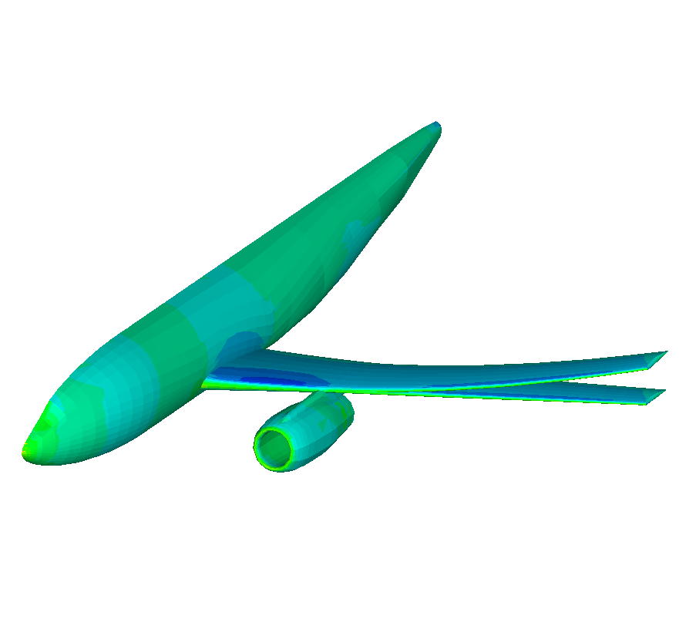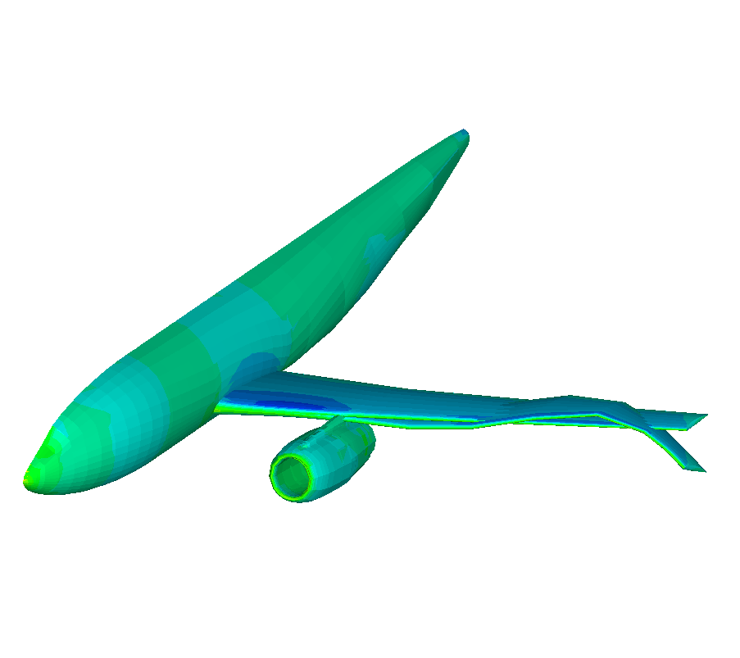
Figure 1: Mapping of modes for a generic passenger jet.

3 Calculation of BIFURCATION
3.1 Review of Eigenvalue Based Methods
Computational aeroelasticity is predominantly based on time domain analysis. Stability is analysed by a parametric search, with the divergence or otherwise of the time response to an initial disturbance being used to indicate the stability. This is inconvenient from the point of view of computational cost. This cost is driven up as the range of frequencies retained in the structural increases, and as the complexity of the modal interactions requires longer calculations to make the dynamics clear. For properly resolved solutions for realistic problems the number of time steps required is several thousand (20 steps per cycle for the highest frequency for at least 5 cycles at the lowest frequency which might be 20 times lower than the highest frequency leading to an estimate of 2000 time steps) and not the few hundred that is quoted based on experience with the unrepresentative AGARD wing. However, for analysing particular conditions already identified time domain analysis is a powerful and general tool.
An effort has been put into analysing stability based on the eigenvalue behaviour of the Jacobian of the semi-discrete residual given above. This was first done for a symmetric aerofoil with two degrees of freedom [8]. The fluid and structural equations were augmented by an equation for a purely imaginary eigenvalue. This system was solved using Newton's method. Approximations were made to make the direct solution of the linear system for the updates more tractable.
A robust method by using an iterative linear solver [9]. The method was extended to three dimensional cases [4]. The extension of the approach to unsymmetric problems, when the steady state depends on the bifurcation parameter, is problem since the second Jacobian is needed to drive the Newton iterations. To avoid this problem, the classical shifted inverse power method (IPM) was adapted to track eigenvalues as the dynamic pressure changes [10]. This method solves a system very similar to the augmented system, but the steady state can be updated for each value of the dynamic pressure before the eigenvalue is calculated. The aeroelastic system eigenvalues is calculated as a function of the bifurcation parameters.
The main difficulty with the inverse power method is associated with the parallel implementation. The convergence of the inverse power iterations requires a good shift for rapid convergence. However, the linear system becomes more ill-conditioned as the shift improves. The main work associated with the all of the eigenvalue based methods is associated with solving a large sparse linear system. Krylov subspace iterative methods are used for this. Block Jacobi incomplete LU decomposition of the Jacobian of the first order spatial discretisation is used as a preconditioner. As the number of processors is increased however the preconditioner becomes worse, and combined with the ill-conditioning generated by good shifts, the method becomes less competitive. The solution to this problem is summarized in the next section.
3.2 Schur Method
The problem tackled in reference [11] is to formulate a method that can calculate the aeroelastic eigenvalues (defined as the normal modes under load from the aerodynamics) for aircraft sized models. This implies a method that does not suffer from the ill-conditioning which arises for the linear systems from the inverse power method, and that can be implemented in parallel. The eigenvalue problem can be written as
$\left[\begin{matrix}A_{\text{ff}} & A_{\text{fs}} \\ A_{\text{sf}} & A_{\text{ss}}\end{matrix}\right]p=λp$
where $A_{\text{ij}}$ is a Jacobian matrix of the fluid (i=f) or structural (i=s) residual with respect to the fluid unknowns (j=f) or structural (j=s) unknowns. The calculation of the terms in this matrix is non-trivial but was discussed in detail in reference [4].
Now, it can be shown that if $λ$is not an eigenvalue of $A_{\text{ff}}$, then it is a solution of the nonlinear eigenvalue problem $S(λ)p_{s}={λp}_{s}$ where $S(λ)=A_{\text{ss}}−A_{\text{sf}}(A_{\text{ff}}−λI)^{−1}A_{\text{fs}}$. The nonlinear eigenvalue problem is solved using Newton’s method. A few simplifications make this a powerful approach. It is necessary to avoid forming $S$ through solving $(A_{\text{ff}}−λI)^{−1}A_{\text{fs}}$ every time $λ$and $μ$changes. To achieve this the expansion $(A_{\text{ff}}−λI)^{−1}≈A_{{\text{ff}}^{−1}}+{λA}_{\text{ff}}^{−1}A_{\text{ff}}^{−1}+\text{.}\text{.}\text{.}\text{.}$ is used. This is only valid for small values of $λ$but this limitation can be overcome by using a shift $λ_{0}$in the eigenvalue equation (the normal mode frequency is used as the shift). The nonlinear eigenvalue is then modified with $S(λ)=A_{\text{ss}}−A_{\text{sf}}((A_{\text{ff}}−λ_{0}I)^{−1}+λ(A_{\text{ff}}−λ_{0}I)^{−1}(A_{\text{ff}}−λ_{0}I)^{−1})A_{\text{fs}}$. A preliminary calculation is made for $(A_{\text{ff}}−λ_{0}I)^{−1}A_{\text{fs}}$ and $(A_{\text{ff}}−λ_{0}I)^{−1}(A_{\text{ff}}−λ_{0}I)^{−1}A_{\text{fs}}$, and then S can be evaluated with a very cheap calculation for any combination of $λ$ and $μ$. Then, the eigenvalue can be traced for varying altitude to identify the onset of flutter by solving the small dimension nonlinear system a number of times. Note that the shift used ($λ_{0}$) is not an eigenvalue of $A_{\text{ff}}$and hence the problem of ill-conditioning is eased. The block Jacobi ILU preconditioner now remains effective as the number of processors increases.
Note that the fluid part of the eigenvector can then be calculated from solving$(A_{\text{ff}}−λI)p_{f}=−A_{\text{fs}}p_{s}$. Also, the adjoint eigenvalue problem
${\left[\begin{matrix}A_{\text{ff}} & A_{\text{fs}} \\ A_{\text{sf}} & A_{\text{ss}}\end{matrix}\right]}^{T}q=λq$
can be solved from $S(λ)^{T}q_{s}={λq}_{s}$ and $(A_{\text{ff}}^{T}−λI)q_{f}=−A_{\text{sf}}^{T}q_{s}$.
4 MODEL REDUCTION
The calculation of the onset of instability is only one part of the problem. It is also important to know the damping before stability is lost (since this is what is measured in flight tests) and the amplitude of limit cycles which develop. To avoid going back to time marching the full order coupled system, a reduced model is derived. This model exploits information computed from the stability calculation described above which provides the bifurcation parameter, the critical eigenvalue and the critical eigenvector (of the original and adjoint problems). The method was described in reference [10] and is summarised here.
First, the fluid and structural unknowns from the full order system are projected onto the eigenvectors for the original problem as $w=zp+\bar{z}\bar{p}+y$where $y$is the part of the solution in the non-critical space. The residual is expanded in a Taylor Series about the equilibrium at the bifurcation point. The expansion is projected against the adjoint eigenvector $q$, leading to a complex equation for $z$. There are two technicalities here. First, second and third Jacobian-vector products are required which are computed using matrix-free products (which requires extended order arithmetic to be used). Secondly, the centre-manifold theory is used to compute the contributions of $y$to the response of $z$. The equation for $z$is parameterised in $μ$through further Taylor expansions. The full order system response (either damped or limit cycle) can then be computed by solving the two degree of system for the chosen parameter value, a calculation that can be done at a very low computational cost.
5 RESULTS
5.1 Matched Goland Wing
The Goland wing has a chord of 6 feet and a span of 20 feet. It is a rectangular cantilevered wing with a 4% thick parabolic section. The structural model follows the description given in reference [12]. The CFD grid is block structured and uses an O-O topology. The fine grid has 236 thousand points. Four mode shapes were retained for the aeroelastic simulation – first bending (1.72 Hz), first torsion (3.05 Hz), second bending (9.18 Hz) and second torsion (11.10 Hz). The wing is very flexible, but features a shock driven limit cycle oscillation at high subsonic Mach numbers. This makes it a useful test case for the methods described above.
In this section we show a matched flutter prediction using the Schur method. A full set of results for this case was presented in reference [11]. The Mach number is fixed at 0.8 and the altitude at which flutter starts is calculated. The matrices $(A_{\text{ff}}−λ_{0}I)^{−1}A_{\text{fs}}$ and $(A_{\text{ff}}−λ_{0}I)^{−1}(A_{\text{ff}}−λ_{0}I)^{−1}A_{\text{fs}}$ were first calculated using from the normal mode frequencies. Then the nonlinear eigenvalue problems were computed for altitude values between -10 and 30 thousand feet. The real and imaginary parts of the eigenvalues are shown in figure 2. Flutter is obtained at about 22 thousand feet when the torsion mode goes unstable. No strong shock waves are present at this Mach number and the flutter speed predicted is in close agreement with linear predictions using NASTRAN. The cost of calculating the flutter altitude is about 13.5 times that of a steady state solution. The nonlinear eigenvalue problems are solved in around 3 steps for each eigenvalue, and the mode tracking was robust.

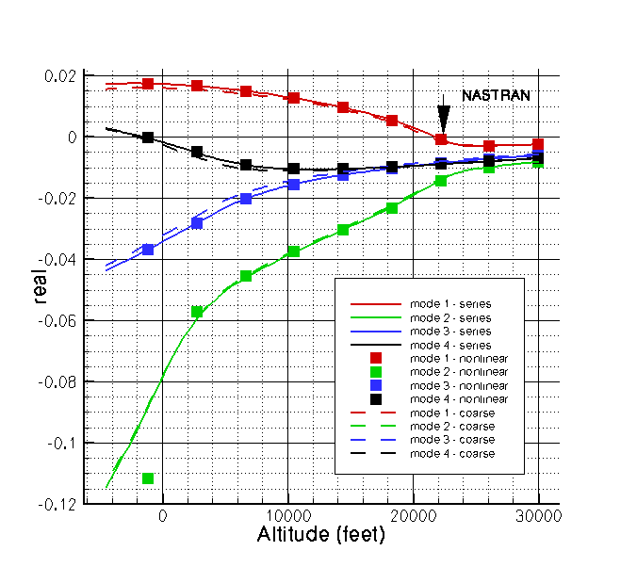 | 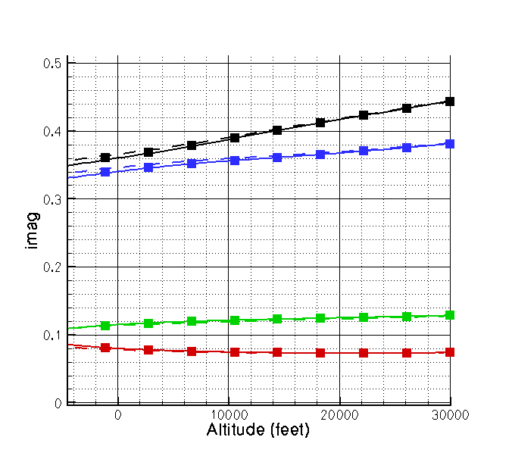
Figure 2: Goland wing at Mach 0.8 – real and imaginary parts of aeroelastic eigenvalues. [11]

5.2 Generic Fighter Model
To test the bifurcation onset calculation using the Schur method a generic fighter test case was constructed. A view of the CFD surface and structural grids is shown in figure 3 [11]. The vertical and horizontal tails have not been included in the current case. The wing has a NACA64A204 section, and is twisted nose down 2.3 degrees from the root to the tip. The aircraft dimensions have been roughly based on the F-16. The has 890 thousand points and 240 blocks. The points are concentrated on the wing which contributes most to the aeroelastic response.
The structural model used shell elements whose thickness varies from 0.75m at the root to 0.05m at the tip. The material properties of aluminum were used. The first symmetric wing bending mode is at 5 Hz and the wing torsion at 16 Hz, which are close to the values for the F-16 clean wing quoted in the literature. To obtained flutter near the flight envelope the structure was then weakened by reducing the Young’s modulus by a factor of 2.5. The mapped second and third modes are shown in figure 4 Ten modes in total were retained for the flutter calculations.
The variation of the real and imaginary parts of the modes is shown for Mach 0.85 in figure 5. The symmetric wing bending mode interacts with the symmetric and asymmetric wing torsion modes to produce flutter at about 3000 metres below seas level. In this case the matrices for the Schur method took 60 times the cost of a steady state calculation to compute on 32 processors of a linux cluster.

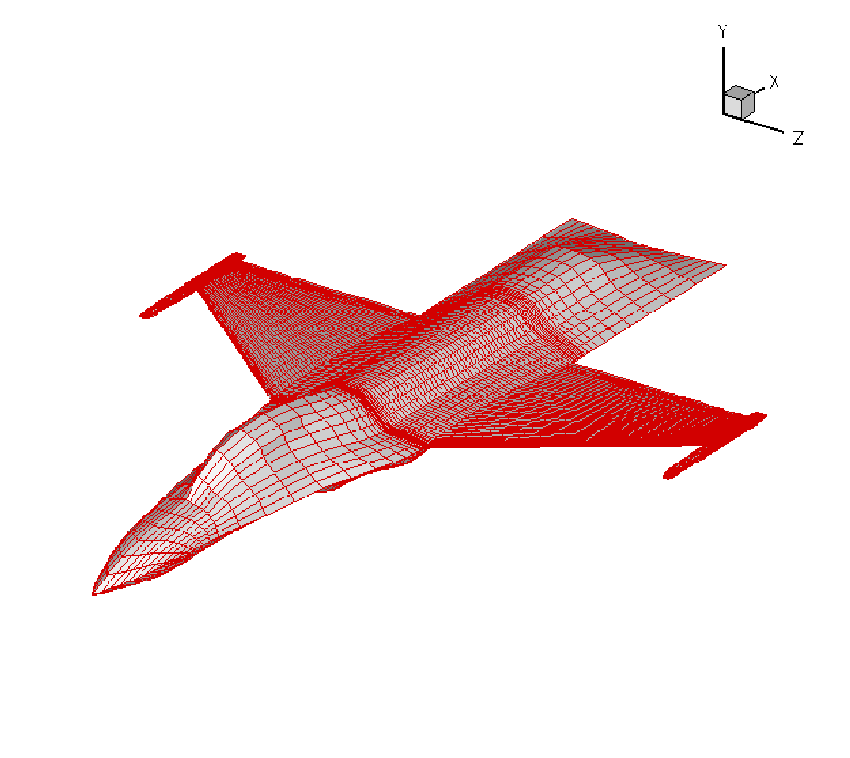 | 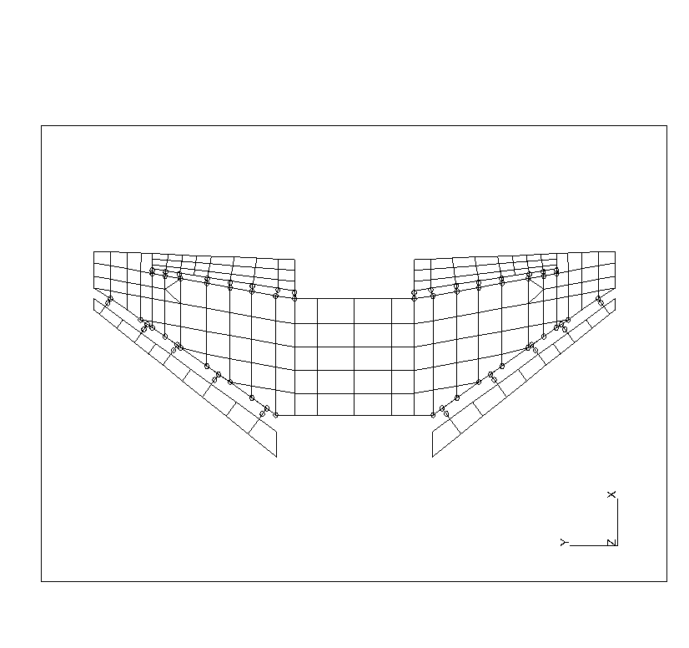
Figure 3: View of the CFD surface grid and the structural grid for the Generic Fighter test case [11]

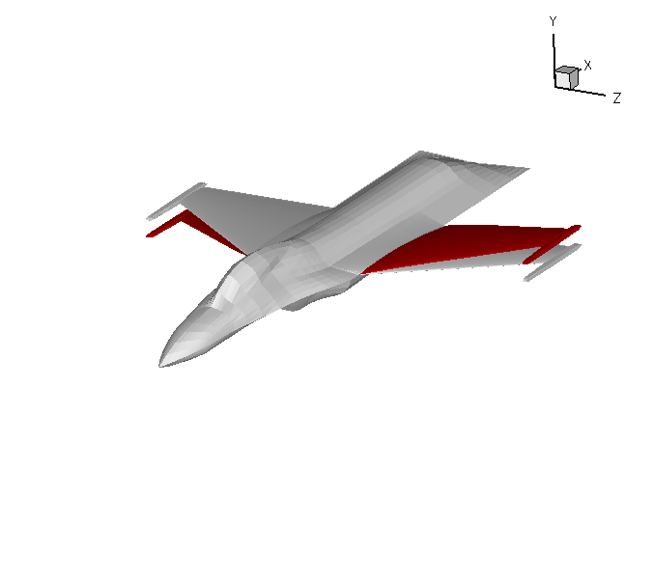 | 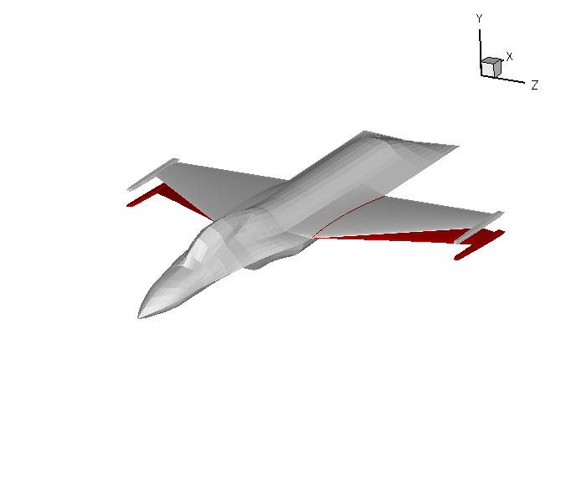
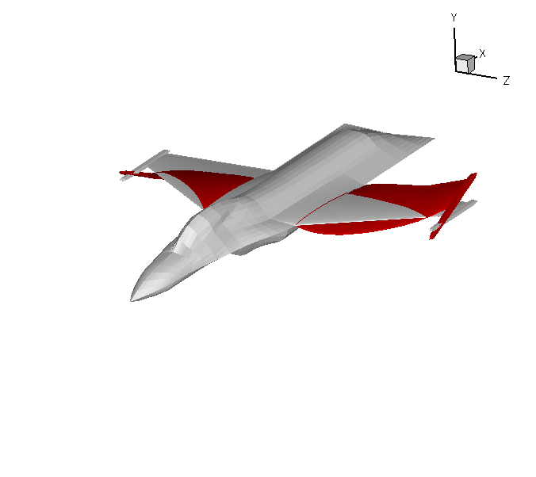 | 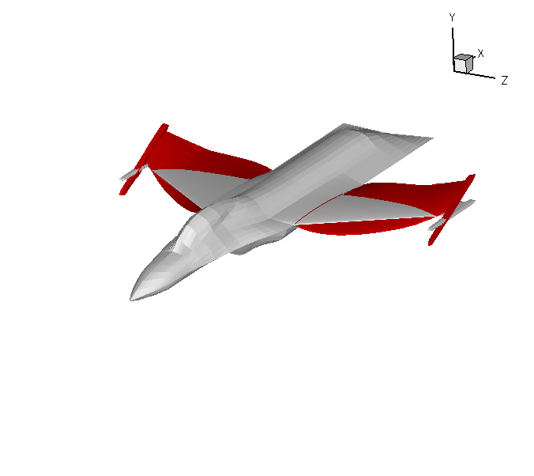
Figure 4: Mapped modes for Generic Fighter – symmetric wing first bending and asymmetric first wing torsion [11]

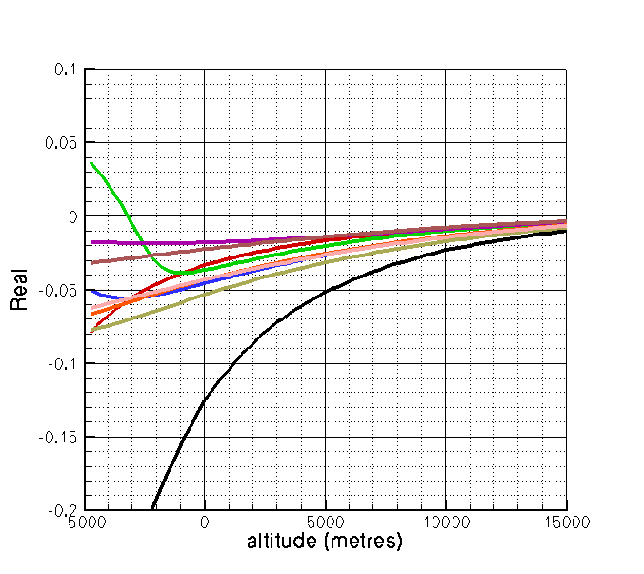 | 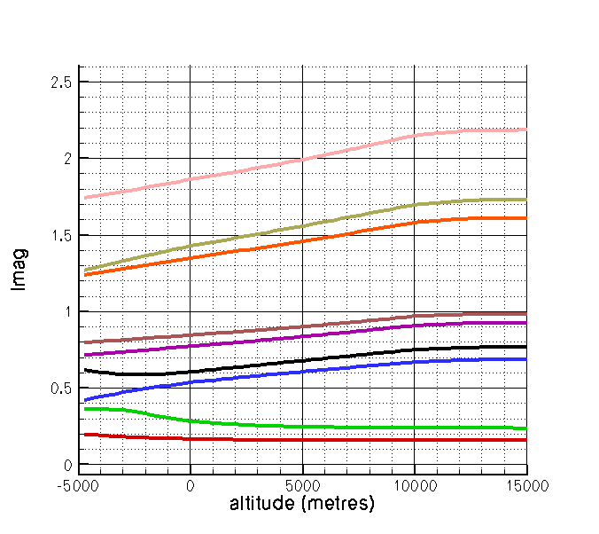
Figure 5: Eigenvalue dependence on altitude for Generic Fighter Test case at M=0.85. [11]

5.3 Wing Rock
To provide a different test to the methods described above the onset angle for the wing rock of an 80 degree delta wing was computed [13]. In this case the structural model describes rigid body rolling motion. The instability is driven by the interaction of the leading edge vortices. A sharp leading edge delta wing is used and the flow is predicted using the Euler equations (with the sharp leading edge fixing the separation point to make this reasonable). The grid used has 200 thousand points.
The onset angle was computed by observing the sign of the real part of the critical eigenvalue as between 16 and 17 degrees, and this is in agreement with time domain results. On a coarse grid extracted from the fine grid by discarding every second point, the onset angle was calculated as 22.4 degrees.
For this case, on the coarse grid, the limit cycle response was computed using the model reduction. The amplitude comparison with the time domain full order system predictions is compared in figure 6. The full order system here has 150 thousand degrees of freedom and each calculation took 1-2 days for the limit cycle to develop fully. The reduced model calculations were made using the critical 2 degrees of freedom, and the setup of the reduced model took less than 30 minutes to compute. The agreement between the two sets of results becomes worse as the angle increases from the onset angle (due to the Taylor expansion used), but is nonetheless in good agreement.

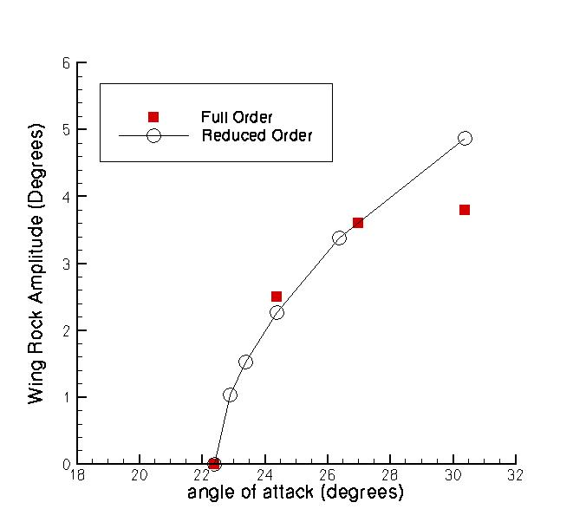
Figure 6: Comparison of Wing Rock Limit Cycle Amplitude between reduced and full order system predictions [13]

5.4 Unmatched Goland Wing LCO
Finally, limit cycle responses [10] using the reduced model for the Goland wing are shown. Given that the Goland wing is always unstable at Mach 0.92 for matched calculations, unmatched calculations are used to test the LCO prediction at this Mach number. The unmatched flutter speed is first calculated for a fixed sea level density. The reduced model is then computed and the growth of the limit cycle computed at higher velocities. Comparison of the LCO amplitude growth with full order comparisons is shown in figure 7. Again good agreement is obtained between the two sets of results. The computing time needed to generate the reduced model, including calculating the flutter speed, was 160 times the steady state cost. The time for one full order calculation to settle to the limit cycle was over 1000 times the steady state cost (indicating that many cycles were needed, especially close to the flutter point).

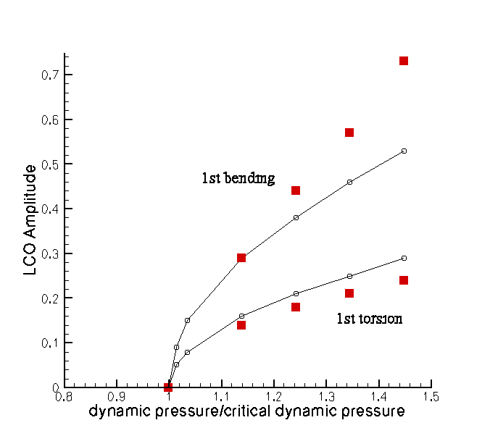
Figure 7: Comparison of Goland Wing Limit Cycle Amplitude between reduced and full order system predictions for unmatched calculations at M=0.92. [10]
6 CONCLUSIONS
A method which allows the tracing of aeroelastic eigenvalues based on the Schur complement was described. The key to the success of the method is the avoidance of having to solve shifted matrices that are almost singular. Results for a generic fighter show the ability of the method to cope with reasonably sized models. The method provides information about the interaction of modes under the influence of the nonlinear aerodynamics.
Building on the output of the stability calculation, which is the flutter speed, the critical eigenvalue and the critical eigenvector, a projection method to develop a nonlinear two degree-of-freedom reduced model was developed. This model was applied to wing rock and Goland wing limit cycle predictions, and gave similar results to predictions of the full order system.
The next development of these methods is a parallel version of the model reduction to allow large model limit cycles to be calculated.
- Acknowledgements
The development of the Schur method was funded by the European Union for the Marie Curie Excellence Team ECERTA under contract MEXT-CT-2006 042383. The model reduction work for the aeroelastic problems and the development of the inter-grid transformation methods was supported by EPSRC, MoD and BAE SYSTEMS and forms part of the work programme of the Partnership for Unsteady Methods Defence and Aerospace Research Partnership (PUMA DARP). The wing rock work was sponsored by the Air Force Office of Scientific Research, Air Force Material Command, USAF, under grant number FA8655-06-1-3033. The U.S. Government is authorized to reproduce and distribute reprints for Government purpose notwithstanding any copyright notation thereon. The views and conclusions contained herein are those of the authors and should not be interpreted as necessarily representing the official policies or endorsements, either expressed or implied, of the Air Force Office of Scientific Research or the U.S. Government.
- References
- Osher,S. and Chakravarthy, S.R., Upwind Schemes and Boundary Conditions with Applications to Euler equations in General Coordinates , Journal Computational Physics, vol. 50 , 1983, p 447-481.
- Van Leer, B., Towards the Ultimate Conservative Conservative Difference Scheme II: Monotonicity and Conservation Combined in a Second Order Scheme, Journal Computational Physics, 14, 361-374, 1974.
- Badcock, K.J., Richards, B.E., and Woodgate, M.A., Elements of Computational Fluid Dynamics on block structured grids using implicit solvers, Prog. Aerospace Sci., Vol. 36, pp 351-392, 2000.
- Badcock, K.J., Woodgate, M.A. and Richards, B.E., Direct Aeroelastic Bifurcation Analysis of a Symmetric Wing Based on the Euler Equations, Journal of Aircraft, 42(3),731-737, 2005.
- Goura, G.S.L., Badcock, K.J., Woodgate, M.A. and Richards, B.E., Implicit method for the time marching analysis of flutter, Aeronautical Journal, 105(1046), 2001, 199-214.
- Goura, G.S.L., Badcock, K.J. and Woodgate, M.A., Extrapolation Effects on Coupled Computational Fluid Dynamics/Computational Structural Dynamics Simulations, AIAA Journal, 41(2), February, 2003, 312-314.
- Badcock, K.J., Rampurawala, A.M. and Richards, B.E., Intergrid Transformation for Aircraft Aeroelastic Simulations, AIAA Journal, Volume 42, Issue 9, pp. 1936-1932, 2005.
- Morton, S.A. and Beran, P.S., Hopf-Bifurcation Analysis of Airfoil Flutter at Transonic Speeds, Journal of Aircraft, 36, pp 421-429, 1999.
- Badcock, K.J., M.A. Woodgate, M.A. and Richards, B.E., The Application of Sparse Matrix Techniques for the CFD based Aeroelastic Bifurcation Analysis of a Symmetric Aerofoil, AIAA Journal, 42(5), 883-892, May, 2004.
- Woodgate, M.A. and Badcock, K.J., On the fast prediction of Transonic Aeroelastic Stability and Limit Cycles, AIAA Journal, 45(6), 2007, 1370-1381.
- Badcock, K.J. and Woodgate, M.A., Prediction of Bifurcation Onset of Large Order Aeroelastic Models, in the proceedings of the 49th AIAA Structures, Structural Dynamics and Materials Conference, Schaumberg, Illinois, 7-10 April, 2008, AIAA-2008-1820.
- Beran, P.S., Knot, N.S., Eastep, F.E., Synder, R.D. and Zweber, J.V., Numerical Analysis of Store-Induced Limit Cycle Oscillarion, Journal of Aircraft, 41(6), 1315-1326, 2004.
- Badcock, K.J., Woodgate, M.A., Allan, M.R. and Beran, P.S. (2008) Wing Rock Limit Cycle Oscillation Prediction Based on Computational Fluid Dynamics. to appear in the AIAA Journal.

